**Chandana Apparels**



**Payroll System**

**DCSD 12.2**

H.M.T. Gihan DKU122027

G.M.R.N. Ariyarathna DKU122006

Janith Madhushan

Amal Jayawardhana

National Institute Of Business Management

Preface

A payroll system involves every thing that has to be done with the payment of employees and filling of employee taxes and keeping tracks of hours, calculating wages, with holding taxes and other deductions, printing and delivering checks and paying employee taxes to the GVT and etc.

Considering al those above facts and the requirements of **Chandana Apparels**, we have successfully completed payroll software for their existing manual payroll system.

This is our DCSD 12.2 final group project for the Diploma in Computer System Designing at National Institute of Business Management Kurunegala. This project refers how we have done it step by step.

Our group members are:-

H.M.T. Gihan

G.M.R.N. Ariyarathna

Amal Jayaardhana

Janitha Madhushan

Acknowledgment

We have taken efforts in this project. However, it would not have been possible without the kind support and help of many individuals and the organization. I would like to extend my sincere thanks to all of them.

We are highly indebted to **Chandana Apparels** and for their guidance and constant supervision as well as for providing necessary information regarding the project & also for their support in completing the project & employees of Chandana **Apparels** for their kind co-operation and encouragement which help me in completion of this project.

Special thanks goes to Mr. (name) who is former manager of **Chandana Apparels** .

I would like to express my gratitude towards our course director of DCSD of NIBM Mr. Shafraz sir giving such a big opportunity to complete this project.

I would like to express my special gratitude and thanks to industry persons for giving me such attention and time including clerks, accountants, and employees too.

Our thanks and appreciations also go to my colleague in developing the project and people who have willingly helped me out with their abilities.

Summary of the Project

This Project is about the payroll system of the **Chandana Apparels.**  And first we have discussed about the existing manual payroll system by dividing it in to 4 main processes. There we try to emphasize its drawbacks and difficulties they would face and the importance of a computerized payroll system.

Including all the information of an employee which is taken through the HRM Department and considering other necessary entities we have drawn dataflow diagrams. By drawing these diagrams we got the general structure of the payroll system. We have included many data stores to keep data separately so any one can get the idea easily. (Dataflow diagrams designed by MS Visio 2010)

Reading the company’s reports and bills etc, we have designed files and the interfaces. (Interfaces designed by Visual Studio 2010) After that according to the interfaces we wrote psuedocodes. Also we included real coding to some of our interfaces. And to get outputs we added a function to generate several reports as given below

* EPF and
* ETF Report
* OT Report
* No pay Report
* Pay Sheet
* Remittance Report

By considering these reports it is easy to find the needed details accurately and in efficient manner. Some of the reports have to send to central bank and also some are sent to the accountant and employee too. We successfully completed the project in this manner.

Finally we talked to the manager **Mr. (name)** and got his idea and we analyzed the benefits of the proposed system. And we included that one also

CONTENTS

Title ………………………………………………………………………………………………………………………………………………………. 1

Preface …………………………………………………………………………………………………………………………………………………. 1

Acknowledgement ……………………………………………………………………………………………………………………………….. 2

Summary of the Project ……………………………………………………………………………………………………………………….. 3

Introduction

Terms of Reference ………………………………………………………………………………………………………………………………. 8

Feasibility Study ……………………………………………………………………………………………………………………………………. 9

Methodology ……………………………………………………………………………………………………………………………………… 10

Duration ……………………………………………………………………………………………………………………………………………… 11

Existing System

History of the Garment ……………………………………………………………………………………………………………………… 13

Existing System ……………………………………………………………………………………………………………………………………. 14

Context Diagram for the existing system …………………………………………………………………………………………….. 15

Drawbacks …………………………………………………………………………………………………………………………………………… 15

Proposed System

System proposed ………………………………………………………………………………………………………………………………… 17

Security ………………………………………………………………………………………………………………………………………………. 18

**Design of the Proposed System**

Data flow Diagrams

Context Diagram for the Proposed System ………………………………………………………………………………………… 21

Level 0 diagram for the Proposed System ………………………………………………………………………………………….. 16

Level 1 diagram for the Adding Data …………………………………………………………………………………………………..

Level 1 diagram for the EPF, ETF, OT, No pay Process ………………………………………………………………………….

Level 1 diagram for the Salary Calculation Process ……………………………………………………………………………..22

Level 1 diagram for the Report Generation Process …………………………………………………………………………….

Designed Files

File List …………………………………………………………………………………………………………………………………………………

File Structures ………………………………………………………………………………………………………………………………………

Program Structure

Program List ………………………………………………………………………………………………………………………………………….

Programs ………………………………………………………………………………………………………………………………………………

Screen Designing

Screen List …………………………………………………………………………………………………………………………………………….

Screens …………………………………………………………………………………………………………………………………………………

Message Layouts …………………………………………………………………………………………………………………………………..

Reports

Report List …………………………………………………………………………………………………………………………………………….

Report Layout ……………………………………………………………………………………………………………………………………….

**Cost and Advantages of the Proposed System**

Requirements ……………………………………………………………………………………………………………………………………… 12

Cost and Advantages ……………………………………………………………………………………………………………………………

Final Conclusion …………………………………………………………………………………………………………………………………..

Chapter 1

Introduction

Terms of Reference

We got the legal permission from the **Chandana Apparels**. Then we proposed a new computerized payroll system for the manual system of their garment by considering their needs. Our main aim was to give the best way to accomplish their requirements.

Efficiency and accuracy is highly improved by this system. Inserting, Updating, Deleting, Searching processes can be done correctly and quickly. To implement this project we need hardware and software too. And also a trained employee is needed to handle this because money transaction is directly done through this system.

Following are steps we followed to give the best performing software.

1. Study the current procedures in the system.
2. Point the weaknesses of the prevailing system.
3. Identify new needs of the employees.
4. Provide simple and best software to the garment.
5. Show the advantages of the proposed one.

Feasibility Study

Feasibility study was done by various methods such as interviewing, observing, record reading, reviving past records and etc. That was the first step we took to start our project. We interviewed manager, accountant, clerks, peon, other employees and etc. We spent more than 2 weeks to collect them and study them well together. We took such a long time because it was very important to see what they are looking for. Then we proposed a new computerized payroll system to the above garment. The facts we considered were mainly accuracy and efficiency, way to get reports etc. Actually we studied the history of the garment too.

We determined whether the proposed system conflicts with legal requirements and focused on the technical resources of the garment and also we got a rough idea about the cost for our software and what they hope from us. Then we moved in to our next step.

Methodology

We have described this briefly in the Summery of the Project also.

After the Feasibility study we followed the steps of the System Development Life Cycle (SDLC). They were.

* Project Planning.
* Project Analysis.
* System Designing.

Then we used the main analysis technique, data flow diagrams (DFD) to show the processes of the system. We hope to use Microsoft Access to connect the database which includes all the information of Employees.

And we are going to use vb.net and C# languages to implement this software in runtime environment.

Duration

After we collected enough data we started our project in middle of August month. We drew a rough project plan and share our ideas with our group members. This is how we spent time on the project.

Data Collection : 2 weeks

Data Analysis : 3 weeks

System Designing and Report Writing : 2 months

Chapter 2

Existing System

History of the Organization

The wearing of clothing is exclusively a human characteristic and is a feature of most human societies. It is not known when humans began wearing clothes. [Anthropologists](http://en.wikipedia.org/wiki/Anthropology) believe that animal skins and vegetation were adapted into coverings as protection from cold, heat and rain, especially as humans migrated to new climates; alternatively, covering may have been invented first for other purposes, such as magic, decoration, cult, or prestige, and later found to be practical as well.

[Clothing](http://en.wikipedia.org/wiki/Clothing) and [textiles](http://en.wikipedia.org/wiki/Textile) have been important in human history and reflects the [materials](http://en.wikipedia.org/wiki/Material) available to a civilization as well as the technologies that it has mastered. The [social](http://en.wikipedia.org/wiki/Social) significance of the finished product reflects their [culture](http://en.wikipedia.org/wiki/Culture).

Textile industry is changing rapidly among people with the time. Nowadays people are looking for new fashionable clothing to act different and to keep their place in the society. Not like in early days, people have dozens of clothes and they offer may be half of their salary to shop keepers. This really has helped to widen this business in our country. And for that people have used many strategies to get the attention of people. This was the beginning of intercession of computerized systems in the industry to make them quick and accurate.

In 1999 Father of former manager at **Chandana Apparels** Mr. (name) started this garment at (place) with five workers and two sewing machines. But today this garment has provided more than 100 job opportunities. And they have uprooted their brand name somewhat too.

First this was started in a house and not so far away from the present location. But today it has spread over about 3 hectares with 5 sectors

* Cutting section
* Sawing section
* Stoking section
* Management section
* Security section

This garment provides many types of clothes such as baby, men, women and sport wearing to island wide shops. That the bit about the organization history.

Existing System

Basic Salary

Salary is given to an employee according to their designation and qualifications.

Gross Salary

This is calculated from basic salary after making increments and deductions.

Over Time

This is calculated when an employee has worked more than normal hours.

Draw Backs

Draw Backs of the Existing System.

* More time consuming.
* Low accuracy.
* High Redundancy.
* Security Problems.
* Wastage of more papers.
* High error rate.

Chapter 3

Proposed System

Application Proposed

We have proposed a computerized payroll system for the existing system of Chandana Apparels to fulfill their requirements.

Our proposed system consists of 13 files. E use them to store employee details, leave info and data those are needed to make the calculation of salary. There must be a trained person to enter those details. Then the salary is calculated automatically by the system.

This system is easy to use and also accuracy is very high when we compare with the existing manual system. And also we can generate reports quickly after entering those details. Human errors are also can be reduced by this software. And we have managed system to show error messages when we enter invalid data to the system. Therefore no invalid data can be entered. This is brief description about the proposed system.

Security System

No Unauthorized access is granted. This prevents data loss and illegal access. We have used a login window for that. Logged user can do these operations

* Read
* Write
* Modify
* Delete

And also we have used an option to add new users and this can be only done by a logged user. Only administrator can accesses security system and this provides high security level for the system.

Chapter 4

Design of the Proposed System

Chapter 4 Design of the proposed system

Dataflow Diagram

Level 0 DFD for Proposed System



Level 1 DFD for the Salary Calculation Process



Level 1 DFD for the EPF, ETF, OT, No pay Process



Level 1 DFD for the Report Generation Process



Chapter 4 Design of the proposed system

File Design

Files List

|  |  |  |
| --- | --- | --- |
| **File No** | **File Name** | **Page No** |
| SF1 | Login |  |
| SF2 | Signup |  |
| D1 | Employee Master |  |
| D5 | Department |  |
| D4 | Leave Details |  |
| D7 | Promotion |  |
| D2 | Increment |  |
| D5 | Work Hour |  |
| D13 | Pay History |  |
| D11 | Rates Per Hour |  |
| D6 | Bonus |  |
| D12 | Salary |  |
| D10 | EPF |  |
| D11 | ETF |  |
| D8 | OT |  |
| D9 | No pay |  |

Chapter 4 Design of the proposed system

Section File Design

File Structures

Login File

File No : D10

File Name : Login File

Description : Username and password of the system

File Organization : Random

File Type : Reference File

Primary Key : UName

Foreign Key :

Record Size : 16 bytes

|  |  |  |  |
| --- | --- | --- | --- |
| Field Name | Description | Type | Size |
| UName | Username | Char | 10 |
| PWord | Password | Char | 6 |

Signup File

File No : D10

File Name : Signup File

Description : Username and password create for the system

File Organization : Random

File Type : Reference File

Primary Key : UName

Foreign Key :

Record Size : 16 bytes

|  |  |  |  |
| --- | --- | --- | --- |
| Field Name | Description | Type | Size |
| UName | Username | Char | 10 |
| PWord | Password | Char | 6 |

Employ Master File

File No : D1

File Name : Employee Master

Description : Employee Personal File

File Organization : Indexed Sequential

File Type : Master File

Primary Key : EmpNo

Foreign Key :DeptNo, DesigNo

Record Size : 148 bytes

|  |  |  |  |
| --- | --- | --- | --- |
| Field Name | Description | Type | Size |
| EmpNo | Employee Number | Numeric | 5 |
| FName | First Name | Char | 15 |
| LName | Last Name | Char | 20 |
| AddL1 | Address Line 1 | Char | 15 |
| AddL2 | Address Line 2 | Char | 15 |
| AddL3 | Address Line 3 | Char | 10 |
| NIC | NIC Number | Char | 10 |
| Sex | Male/Female | Char | 1 |
| DOB | Date Of Birth | Date | 8 |
| MStatus | Martial Status | Logical | 1 |
| DesigNo | Designation Number | Char | 4 |
| DeptNo | Department Number | Char | 4 |
| BSal | Basic Salary | Currency | 10 |
| DJoin | Date Joined | Date | 8 |
| Status | Permanent/Casual | Logical | 1 |
| TelNo | Home Telephone No | Numeric | 10 |
| OffTP | Office T/P No | Numeric | 10 |
| BaNo | Bank Account No | Numeric | 15 |

Department File

File No : D2

File Name : Department File

Description : Department reference File

File Organization : Indexed Sequential

File Type : Reference File

Primary Key : DeptNo

Foreign Key :

Record Size : 20 bytes

|  |  |  |  |
| --- | --- | --- | --- |
| Field Name | Description | Type | Size |
| DeptNo | Department No | Char | 4 |
| DeptName | Department Name | Char | 16 |

Leave Detail File

File No : D5

File Name : Leave detail File

Description : Leave Transaction File

File Organization : Indexed Sequential

File Type : Transaction File

Primary Key : EmpNo + ItemCode + Year + Month

Foreign Key : EmpNo + ItemCode

Record Size : 23 bytes

|  |  |  |  |
| --- | --- | --- | --- |
| Field Name | Description | Type | Size |
| EmpNo | Employee Number | Char | 5 |
| ItemCode | Item Code | Char | 10 |
| Year | Year | Numeric | 4 |
| Month | Month | Numeric | 2 |
| NoLeaves | No of Leaves | Numeric | 2 |
| NoPay | No of no pay days | Numeric | 3 |

Promotion File

File No : D6

File Name : Promotion File

Description : Promotion Data Of Employee

File Organization : Indexed Sequential

File Type : Transaction File

Primary Key : EmpNo + DesigNo + PromoDate

Foreign Key : EmpNo , DeptNo, DesigNo

Record Size : 41 bytes

|  |  |  |  |
| --- | --- | --- | --- |
| Field Name | Description | Type | Size |
| EmpNo | Employee Number | Char | 5 |
| DesigNo | Designation Number | Char | 4 |
| DeptNo | Department Number | Char | 4 |
| PromoDate | Promoted Date | Date | 8 |
| Description | Remarks | Char | 20 |

Increment File

File No : D7

File Name : Increment File

Description : Increment Data Of Employee

File Organization : Indexed Sequential

File Type : Transaction File

Primary Key : EmpNo + DeptNo

Foreign Key : EmpNo , DeptNo, DesigNo

Record Size : 39 bytes

|  |  |  |  |
| --- | --- | --- | --- |
| Field Name | Description | Type | Size |
| EmpNo | Employee Number | Char | 5 |
| DesigNo | Designation Number | Char | 4 |
| DeptNo | Department Number | Char | 4 |
| IncreAmt | Increment Amount | Currency | 8 |
| BSal | Basic Salary | Currency | 10 |
| IncreDate | Increment Date | Date | 8 |

Work Hour File

File No : D8

File Name : Work Hour File

Description : Details about worked hour of employees

File Organization : Random

File Type : Transaction File

Primary Key : EmpNo + ItemCode + Year + Month

Foreign Key : EmpNo , ItemCode

Record Size : 31 bytes

|  |  |  |  |
| --- | --- | --- | --- |
| Field Name | Description | Type | Size |
| EmpNo | Employee Number | Char | 5 |
| ItemCode | Item Code | Char | 10 |
| Year | Year | Numeric | 4 |
| Month | Month | Numeric | 2 |
| Hours | No of extra hours | Numeric | 10 |

Pay History File

File No : D9

File Name : Pay History File

Description : Details about pay history of employees

File Organization : Random

File Type : Transaction File

Primary Key : EmpNo + Year + Month

Foreign Key : EmpNo

Record Size : 41 bytes

|  |  |  |  |
| --- | --- | --- | --- |
| Field Name | Description | Type | Size |
| EmpNo | Employee Number | Char | 5 |
| Year | Year | Numeric | 4 |
| Month | Month | Numeric | 2 |
| NetPay | NetPay | Currency | 10 |
| TEarn | Total Earning | Currency | 10 |
| TDeduct | Total Deductions | Currency | 10 |

Rates Per Hour File

File No : D11

File Name : Rates Per Hour File

Description : Rates paid per hour to the employee

File Organization : Random

File Type : Reference File

Primary Key :

Foreign Key : ItemCode

Record Size : 20 bytes

|  |  |  |  |
| --- | --- | --- | --- |
| Field Name | Description | Type | Size |
| ItemCode | Types of hour | Char | 10 |
| Rate | Rate per hour | Numeric | 10 |

Bonus File

File No : D12

File Name : Bonus File

Description : Amount of bonus to the employee

File Organization : Random

File Type : Transaction File

Primary Key :

Foreign Key : EmpNo

Record Size : 22 bytes

|  |  |  |  |
| --- | --- | --- | --- |
| Field Name | Description | Type | Size |
| EmpNo | Employee Number | Char | 4 |
| Date | Date Paid | Date | 8 |
| Amt | Amount Paid | Numeric | 10 |

Salary File

File No : D13

File Name : Salary File

Description : Details of the salary paid to the employees

File Organization : Indexed Sequential

File Type : Transaction File

Primary Key : EmpNo + Year + Month

Foreign Key :

Record Size : 61 bytes

|  |  |  |  |
| --- | --- | --- | --- |
| Field Name | Description | Type | Size |
| EmpNo | Employee Number | Char | 5 |
| Year | Year | Numeric | 4 |
| Month | Month | Numeric | 2 |
| BSal | Basic Salary | Currency | 10 |
| TEarns | Total Earnings | Currency | 10 |
| GSal | Gross Salary | Currency | 10 |
| TDeduct | Total Deductions | Currency | 10 |
| NetSal | NetSalary | Currency | 10 |

EPF File

File No : D14

File Name : EPF File

Description : Details of EPF Contribution of employees

File Organization : Indexed Sequential

File Type : Transaction File

Primary Key : EPFNo + Month

Foreign Key : EmpNo

Record Size : 21 bytes

|  |  |  |  |
| --- | --- | --- | --- |
| Field Name | Description | Type | Size |
| EmpNo | Employee Number | Char | 5 |
| EPFNo | Employee Provident Fund Number | Numeric | 4 |
| Month | Month | Numeric | 2 |
| EMPIRate | Employer’s Rate | Numeric | 5 |
| EmplyeeRate | Employees Rate | Numeric | 5 |

ETF File

File No : D14

File Name : ETF File

Description : Details of ETF Contribution of employees

File Organization : Indexed Sequential

File Type : Transaction File

Primary Key : ETFNo + Month

Foreign Key : EmpNo

Record Size : 22 bytes

|  |  |  |  |
| --- | --- | --- | --- |
| Field Name | Description | Type | Size |
| EmpNo | Employee Number | Char | 5 |
| ETFNo | Employee Trust Fund Number | Numeric | 4 |
| Month | Month | Date | 8 |
| EMPIRate | Employer’s Rate | Numeric | 5 |

OT File

File No : D16

File Name : OT File

Description : OT Details of employees

File Organization : Indexed Sequential

File Type : Transaction File

Primary Key : EmpNo + Year+ Month

Foreign Key : EmpNo

Record Size : 25 bytes

|  |  |  |  |
| --- | --- | --- | --- |
| Field Name | Description | Type | Size |
| EmpNo | Employee Number | Char | 5 |
| Year | Year | Numeric | 4 |
| Month | Month | Date | 8 |
| OT Hour | Number of OT Hour | Numeric | 4 |
| OT Rate | OT Rate Per Hour | Numeric | 4 |
| Amount | Amount | Numeric | 8 |

No Pay File

File No : D17

File Name : No Pay File

Description : No Pay Details of employees

File Organization : Indexed Sequential

File Type : Transaction File

Primary Key : EmpNo + Year+ Month

Foreign Key : EmpNo

Record Size : 21 bytes

|  |  |  |  |
| --- | --- | --- | --- |
| Field Name | Description | Type | Size |
| EmpNo | Employee Number | Char | 5 |
| Year | Year | Numeric | 4 |
| Month | Month | Date | 8 |
| NPDays | No Pay Days | Numeric | 4 |

Chapter 4 Design of the proposed system

Programs

Programs List

|  |  |  |
| --- | --- | --- |
| **Program No** | **Program Name** | **Page No** |
| P1 | Login |  |
| P2 | Signup |  |
| P3 | Main Form |  |
| P4 | Search |  |
| P5 | Maintenances |  |
| P6 | Reports |  |
| P7 | Tool |  |
| P8 | Employee Master |  |
| P9 | Department |  |
| P10 | Pay History |  |
| P11 | Rates Per Hour |  |
| P12 | Bonus |  |
| P13 | Salary |  |
| P14 | EPF |  |
| P15 | ETF |  |
| P16 | OT |  |
| P17 | No pay |  |
| P18 | Leave Details |  |
| P19 | Increment |  |
| P20 | Promotion |  |

Chapter 4 Design of the proposed system

Section Programs

Programs Structures

Program 1 Login

Program ID : 01

Description : Login Check

Screen Name : Screen 01

Input File : Login File

Output File :

Output Report :

Begin prg

Display Screen (screen 1)

Input username and password

Button1 Clicked

Open Login File

Find Uname and PWord

If Username and Password Not Found then

Display Error Message (Message screen 04)

Else

Display Screen (screen 2)

If Button2 Clicked

Clear Textbox1 and Textbox2

End Program

Program 2 Signup

Program ID : 01

Description : Login Check

Screen Name : Screen 01

Input File : Login File

Output File :

Output Report :

Begin prg

Display Screen (screen 1)

Input username and password

Button1 Clicked

Open Login File

Find Uname and PWord

If Username and Password Not Found then

Display Error Message (Message screen 04)

Else

Display Screen (screen 2)

If Button2 Clicked

Clear Textbox1 and Textbox2

End Program

Program 3 Main Form

Program ID : 01

Description : Login Check

Screen Name : Screen 01

Input File : Login File

Output File :

Output Report :

Begin prg

Display Screen (screen 1)

Input username and password

Button1 Clicked

Open Login File

Find Uname and PWord

If Username and Password Not Found then

Display Error Message (Message screen 04)

Else

Display Screen (screen 2)

If Button2 Clicked

Clear Textbox1 and Textbox2

End Program

Program 4 Search

Program 5 Maintenances

Program ID : 03

Description : Maintenance Menu

Screen Name : Screen 2.2

Input File :

Output File :

Output Report :

Start

Display Screen (screen 2.1.2)

Disable Buttons(“Save”,”Delete”)

Input

Open File Department

If button1 clicked

Program 6 Report

Program 6 Tool

Program 8 Maintenance > Employee Master

Program 9 Maintenance > Department

Program ID : Program 06

Description : Department

Screen Name : Screen 2.2.2

Input File : Department File

Output File :

Output Report :

Begin program

Open Department file

Display Screen 2.2.2

Input Dept_code and Dept_name

If Add Clicked

If any textboxes are empty except fintxt and deltxt then

Display Error message 1.1

Else

Write the record

Display Message Screen 1.8

End if

Else If Find clicked then

Find Department File DeptCode=Dept_code

If found

Display Record

Else

Display Message Screen (1.1)

End if

Else If Delete Clicked then

If Deltxt empty then

Display Error Message 1.1

Else

Display Message Screen 1.6

If Yes Clicked then

Delete Record

Display Message Screen 1.9

Else

Display Screen 2.2.2

End if

End if

Else If Modify Clicked then

Display Message Screen 1.4

If Yes Clicked then

Update Record

Display Message Screen 2.0

Else

Display Screen 2.2.2

End if

End if

Else If Back Clicked then

Display Screen 2.2.2

End if

End Program

Program 10 Maintenance > Pay History

Program ID : Program 11

Description : Pay History

Screen Name : Screen2.2.7

Input File : Pay HistoryFile

Output File :

Output Report :

Begin Program

Open Leave Details File

Display Screen 2.2.7

Input EmpNo,Year, Month, Net pay,Total Earnings, Total Deduction

If Add Cilcked then

If any textboxes are Empty except findtxt and deltxt then

Display Error Message 1.1

Else

Write the record

Display Message Screen 1.8

End If

Else If Find Clicked then

If findtxt is empty then

Display Error Message 1.1

Else

Find Leave Details EmpNo=Emp_No

If Found Then

Display Records

Else

Display Error Message 1.2

End If

End If

Else If Modify Clicked then

If All textboxes are Empty except findtxt and deltxt then

Display Error Message1.1

Else If Emp No=Emp_No then

Display Message Screen 1.5

If Yes Clicked then

Update Record

Else

Display Screen 2.2.3

End If

End If

Else If Delete Clicked then

If deltext empty then

Display Error Message 1.1

Else

Display Message Screen 1.6

If Yes Clicked then

Delete Record

Display Message Screen 1.9

Else

Display Screen 2.2.7

End If

End If

Else If Back Clicked then

Display Screen 2.2.7

End If

End Program

Program 11 Maintenance > Rates per hour

Program ID : Program 12

Description : Department

Screen Name : Screen 2.2.8

Input File : Rates Per Hour Detail File

Output File :

Output Report :

Begin program

Open Rates Per Hour Details File

Display Screen 2.2.8

Input Desig No And Rate

If Add Clicked

If Any Textboxes are Empty Except Findxt and Deltxt then

Display Error message 1.1

Else

Write the record

Display Message Screen 1.8

End if

Else If Find clicked then

Find Department File DesigNo=Desi_No

If found

Display Record

Else

Display Message Screen (1.1)

End if

Else If Delete Clicked then

If Deltxt empty then

Display Error Message 1.1

Else

Display Message Screen 1.6

If Yes Clicked then

Delete Record

Display Message Screen 1.9

Else

Display Screen 2.2.8

End if

End if

Else If Modify Clicked then

Display Message Screen 1.4

If Yes Clicked then

Update Record

Display Message Screen 2.0

Else

Display Screen 2.2.8

End if

End if

Else If Back Clicked then

Display Screen 2.2.8

End if

End Program

Program 12 Maintenance > Bonus

Program ID : Program 13

Description : Bonus

Screen Name : Screen 2.2.9

Input File : Bonus Detail File

Output File :

Output Report :

Begin program

Open Bonus Details File

Display Screen 2.2.9

Input Emp_No,Date, Amount

If Add Clicked

If Any Textboxes are Empty Except Findxt and Deltxt then

Display Error message 1.1

Else

Write the record

Display Message Screen 1.8

End if

Else If Find clicked then

Find Department File EmpNo=Emp_No

If found

Display Record

Else

Display Message Screen (1.1)

End if

Else If Delete Clicked then

If Deltxt empty then

Display Error Message 1.1

Else

Display Message Screen 1.6

If Yes Clicked then

Delete Record

Display Message Screen 1.9

Else

Display Screen 2.2.9

End if

End if

Else If Modify Clicked then

Display Message Screen 1.4

If Yes Clicked then

Update Record

Display Message Screen 2.0

Else

Display Screen 2.2.9

End if

End if

Else If Back Clicked then

Display Screen 2.2.9

End if

End Program

Program 13 Maintenance > Salary

Program ID : Program 14

Description : Salary

Screen Name : Screen2.2.10

Input File : Salary File

Output File :

Output Report :

Begin Program

Open Leave Details File

Display Screen 2.2.10

Input EmpNo,Year, Month, Basic Salary,TotalEarnings,Gross Sal, Total Deduction, Net Sal

If Add Cilcked then

If any textboxes are Empty except findtxt and deltxt then

Display Error Message 1.1

Else

Write the record

Display Message Screen 1.8

End If

Else If Find Clicked then

If findtxt is empty then

Display Error Message 1.1

Else

Find Leave Details EmpNo=Emp_No

If Found Then

Display Records

Else

Display Error Message 1.2

End If

End If

Else If Modify Clicked then

If All textboxes are Empty except findtxt and deltxt then

Display Error Message1.1

Else If Emp No=Emp_No then

Display Message Screen 1.5

If Yes Clicked then

Update Record

Else

Display Screen 2.2.3

End If

End If

Else If Delete Clicked then

If deltext empty then

Display Error Message 1.1

Else

Display Message Screen 1.6

If Yes Clicked then

Delete Record

Display Message Screen 1.9

Else

Display Screen 2.2.10

End If

End If

Else If Back Clicked then

Display Screen 2.2.10

End If

End Program

Program 14 Maintenance > EPF

Program ID : Program 15

Description : EPF

Screen Name : Screen 2.2.11

Input File : EPF Detail File

Output File :

Output Report :

Begin program

Open EPF Details File

Display Screen 2.2.11

Input Emp_No,Rate,Month,EmployersRate and EmployeesRate

If Add Clicked

If Any Textboxes are Empty Except Findxt and Deltxt then

Display Error message 1.1

Else

Write the record

Display Message Screen 1.8

End if

Else If Find clicked then

Find Department File EmpNo=Emp_No

If found

Display Record

Else

Display Message Screen (1.1)

End if

Else If Delete Clicked then

If Deltxt empty then

Display Error Message 1.1

Else

Display Message Screen 1.6

If Yes Clicked then

Delete Record

Display Message Screen 1.9

Else

Display Screen 2.2.11

End if

End if

Else If Modify Clicked then

Display Message Screen 1.4

If Yes Clicked then

Update Record

Display Message Screen 2.0

Else

Display Screen 2.2.11

End if

End if

Else If Back Clicked then

Display Screen 2.2.11

End if

End Program

Program 15 Maintenance > ETF

Program ID : Program 16

Description : ETF

Screen Name : Screen 2.2.12

Input File : ETF Detail File

Output File :

Output Report :

Begin program

Open ETF Details File

Display Screen 2.2.12

Input Emp_No,Rate,Month and EmployersRate

If Add Clicked

If Any Textboxes are Empty Except Findxt and Deltxt then

Display Error message 1.1

Else

Write the record

Display Message Screen 1.8

End if

Else If Find clicked then

Find Department File EmpNo=Emp_No

If found

Display Record

Else

Display Message Screen (1.1)

End if

Else If Delete Clicked then

If Deltxt empty then

Display Error Message 1.1

Else

Display Message Screen 1.6

If Yes Clicked then

Delete Record

Display Message Screen 1.9

Else

Display Screen 2.2.12

End if

End if

Else If Modify Clicked then

Display Message Screen 1.4

If Yes Clicked then

Update Record

Display Message Screen 2.0

Else

Display Screen 2.2.12

End if

End if

Else If Back Clicked then

Display Screen 2.2.12

End if

End Program

Program 16 Maintenance > OT

Program ID : Program 17

Description : OT

Screen Name : Screen2.2.13

Input File : OT File

Output File :

Output Report :

Begin Program

Open Leave Details File

Display Screen 2.2.13

Input Emp No, ETF No, Month, Employee Rate, OT Rate, Amount

If Add Cilcked then

If any textboxes are Empty except findtxt and deltxt then

Display Error Message 1.1

Else

Write the record

Display Message Screen 1.8

End If

Else If Find Clicked then

If findtxt is empty then

Display Error Message 1.1

Else

Find Leave Details EmpNo=Emp_No

If Found Then

Display Records

Else

Display Error Message 1.2

End If

End If

Else If Modify Clicked then

If All textboxes are Empty except findtxt and deltxt then

Display Error Message1.1

Else If Emp No=Emp_No then

Display Message Screen 1.5

If Yes Clicked then

Update Record

Else

Display Screen 2.2.3

End If

End If

Else If Delete Clicked then

If deltext empty then

Display Error Message 1.1

Else

Display Message Screen 1.6

If Yes Clicked then

Delete Record

Display Message Screen 1.9

Else

Display Screen 2.2.13

End If

End If

Else If Back Clicked then

Display Screen 2.2.13

End If

End Program

Program 17 Maintenance Employee > No pay

Program ID : Program 18

Description : No Pay

Screen Name : Screen 2.2.14

Input File : No Pay Detail File

Output File :

Output Report :

Begin program

Open No Pay Details File

Display Screen 2.2.14

Input Emp_No,Rate, Year, Month and NoPay Days

If Add Clicked

If Any Textboxes are Empty Except Findxt and Deltxt then

Display Error message 1.1

Else

Write the record

Display Message Screen 1.8

End if

Else If Find clicked then

Find Department File EmpNo=Emp_No

If found

Display Record

Else

Display Message Screen (1.1)

End if

Else If Delete Clicked then

If Deltxt empty then

Display Error Message 1.1

Else

Display Message Screen 1.6

If Yes Clicked then

Delete Record

Display Message Screen 1.9

Else

Display Screen 2.2.14

End if

End if

Else If Modify Clicked then

Display Message Screen 1.4

If Yes Clicked then

Update Record

Display Message Screen 2.0

Else

Display Screen 2.2.14

End if

End if

Else If Back Clicked then

Display Screen 2.2.14

End if

End Program

Program 18 Maintenance > Leave Details

Program ID : Program 09

Description : Increment

Screen Name : Screen2.2.5

Input File : Increment File

Output File :

Output Report :

Begin Program

Open Increment File

Display Screen 2.2.5

Input Emp No, Year, Month, No Leave, No Pay

If Add Cilcked then

If any textboxes are Empty except findtxt and deltxt then

Display Error Message 1.1

Else

Write the record

Display Message Screen 1.8

End If

Else If Find Clicked then

If findtxt is empty then

Display Error Message 1.1

Else

Find Leave Details EmpNo=Emp_No

If Found Then

Display Records

Else

Display Error Message 1.2

End If

End If

Else If Modify Clicked then

If All textboxes are Empty except findtxt and deltxt then

Display Error Message1.1

Else If Emp No=Emp_No then

Display Message Screen 1.5

If Yes Clicked then

Update Record

Else

Display Screen 2.2.3

End If

End If

Else If Delete Clicked then

If deltext empty then

Display Error Message 1.1

Else

Display Message Screen 1.6

If Yes Clicked then

Delete Record

Display Message Screen 1.9

Else

Display Screen 2.2.3

End If

End If

Else If Back Clicked then

Display Screen 2.2.3

End If

End Program

Program 19 Maintenance > Work Hour

Program ID : Program 10

Description : Department

Screen Name : Screen 2.2.6

Input File : Work Hour Detail File

Output File :

Output Report :

Begin program

Open Work Hour Details File

Display Screen 2.2.6

Input Emp_Code, Item_Code,Year,Month and Hours

If Add Clicked

If Any Textboxes are Empty Except Findxt and Deltxt then

Display Error message 1.1

Else

Write the record

Display Message Screen 1.8

End if

Else If Find clicked then

Find Department File EmpNo=Emp_No

If found

Display Record

Else

Display Message Screen (1.1)

End if

Else If Delete Clicked then

If Deltxt empty then

Display Error Message 1.1

Else

Display Message Screen 1.6

If Yes Clicked then

Delete Record

Display Message Screen 1.9

Else

Display Screen 2.2.6

End if

End if

Else If Modify Clicked then

Display Message Screen 1.4

If Yes Clicked then

Update Record

Display Message Screen 2.0

Else

Display Screen 2.2.6

End if

End if

Else If Back Clicked then

Display Screen 2.2.6

End if

End Program

Program 20 Maintenance > Increment

Program ID : Program 11

Description : Pay History

Screen Name : Screen2.2.6

Input File : Leave Details File

Output File :

Output Report :

Begin Program

Open Leave Details File

Display Screen 2.2.3

Input EmpNo,DesigNo,Dept No, Increment Amnt, Basic Sal, Icrement Date

If Add Cilcked then

If any textboxes are Empty except findtxt and deltxt then

Display Error Message 1.1

Else

Write the record

Display Message Screen 1.8

End If

Else If Find Clicked then

If findtxt is empty then

Display Error Message 1.1

Else

Find Leave Details EmpNo=Emp_No

If Found Then

Display Records

Else

Display Error Message 1.2

End If

End If

Else If Modify Clicked then

If All textboxes are Empty except findtxt and deltxt then

Display Error Message1.1

Else If Emp No=Emp_No then

Display Message Screen 1.5

If Yes Clicked then

Update Record

Else

Display Screen 2.2.3

End If

End If

Else If Delete Clicked then

If deltext empty then

Display Error Message 1.1

Else

Display Message Screen 1.6

If Yes Clicked then

Delete Record

Display Message Screen 1.9

Else

Display Screen 2.2.5

End If

End If

Else If Back Clicked then

Display Screen 2.2.5

End If

End Program

Program 21 Maintenance > Promotion

Program ID : Program 21

Description : Promotion

Screen Name : Screen 2.2.4

Input File : Department File

Output Fie :

Output Report :

Begin Program

Open Promotion File

Display Screen 2.2.4

Input Emp_No,Desig_No,Dept_No,Promoted_Date,Description

If Find Clicked then

If FindTxt is Empty then

Display Error Message 1.1

Else

Find Promotion File EmpNo=Emp_No

If found then

Display Records

Else

Display Error Message 1.2

End if

End if

Else If Modify Clicked Then

If All Record are Empty except Findtxt and Deltxt then

Display Error Message 1.1

Else if empno=Emp_No then

Display Message Screen 1.5

If Yes Clciked then

Update Record

Else

Display Screen 2.2.4

End if

End if

Else If Back Clicked then

Display Screen 2.2.5

End If

End Program

Chapter 4 Design of the proposed system

Screens

Screen List

|  |  |  |
| --- | --- | --- |
| **Screen No** | **Screen Name** | **Page No** |
| S1 | Login |  |
| S2 | Signup |  |
| S3 | Main Form |  |
| S4 | Search |  |
| S5 | Maintenances |  |
| S6 | Reports |  |
| S7 | Tool |  |
| S8 | Employee Master |  |
| S9 | Department |  |
| S10 | Pay History |  |
| S11 | Rates Per Hour |  |
| S12 | Bonus |  |
| S13 | Salary |  |
| S14 | EPF |  |
| S15 | ETF |  |
| S16 | OT |  |
| S17 | No pay |  |
| S18 | Work Hour |  |
| S19 | Leave Details |  |
| S20 | Increment |  |
| S21 | Promotion |  |

Screen 01 Logging

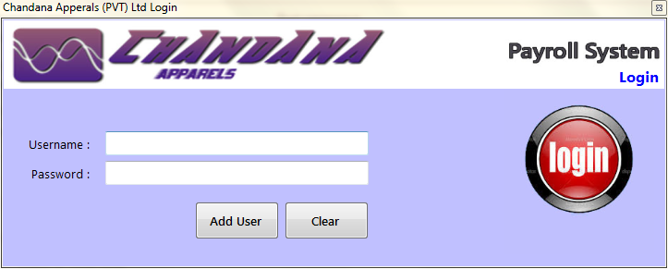

Screen 02 Signup

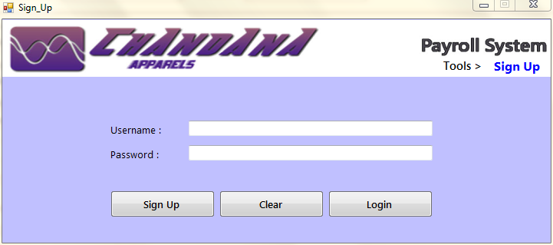

Screen 03 Main Form

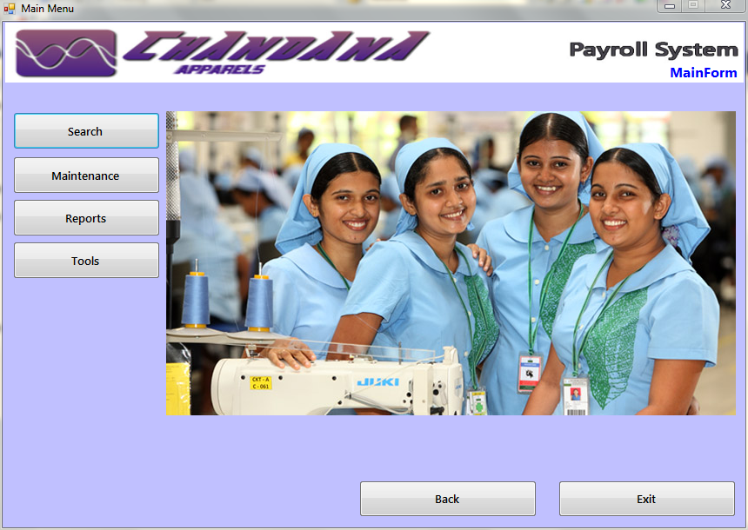

Screen 04 Search

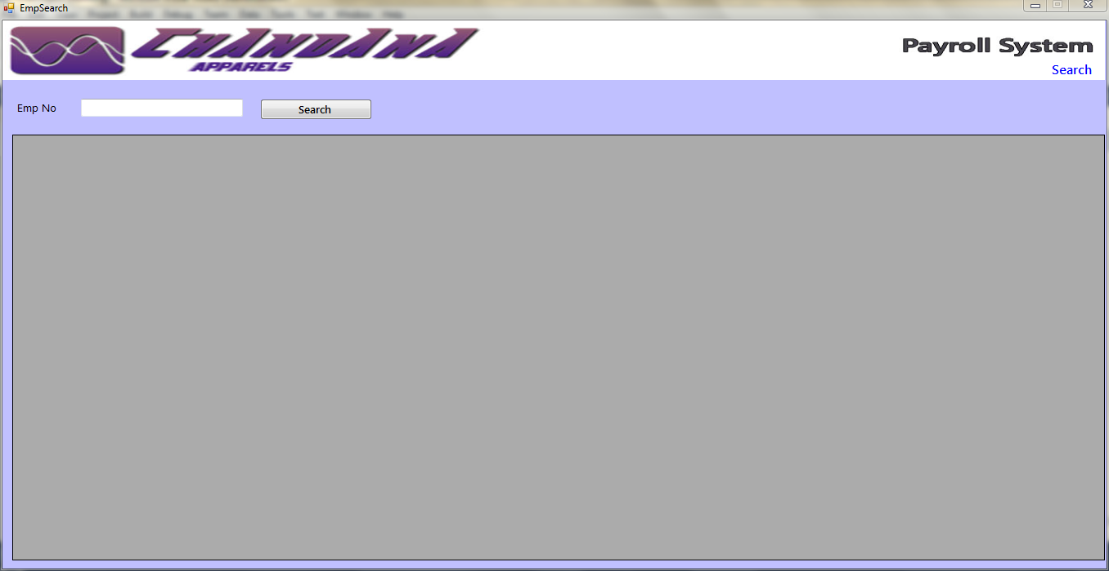

Screen 05 Maintenances

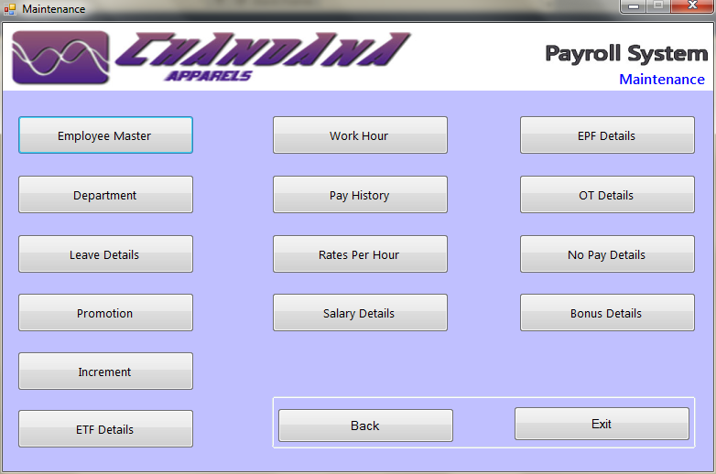

Screen 06 Reports

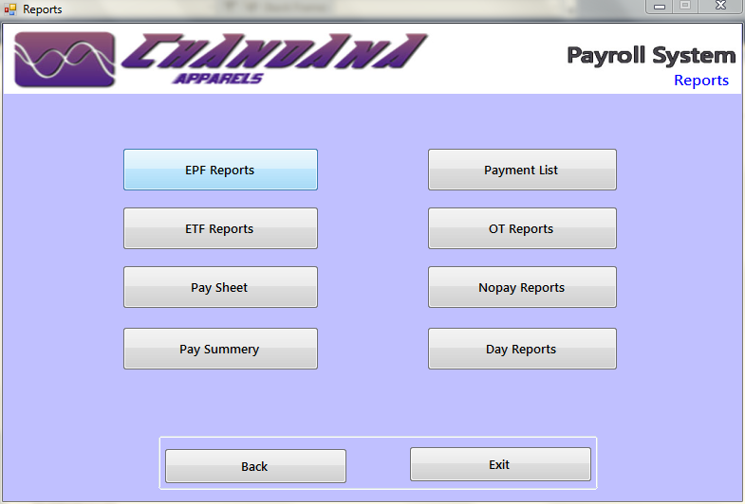

Screen 07 Tool

Screen 08 Employee Master

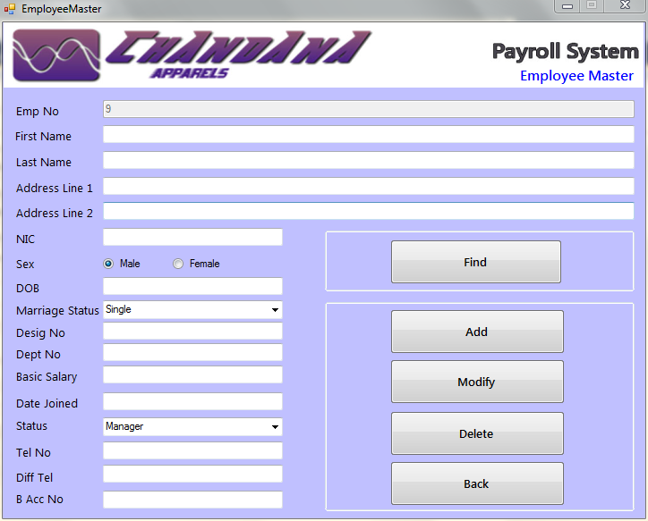

Seen 09 Department

Screen 10 Pay history

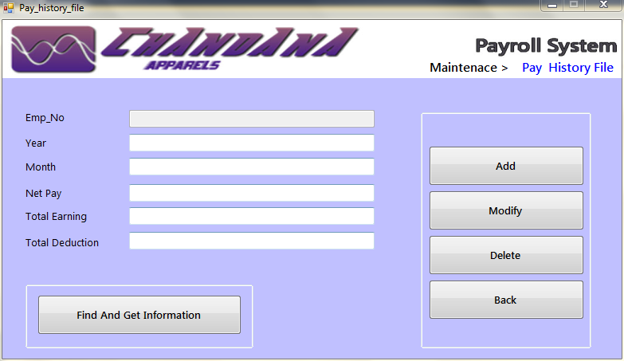

Screen 02 Rates per hour

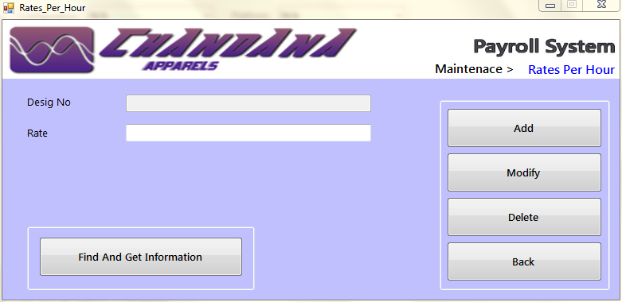

Screen 12 Bonus

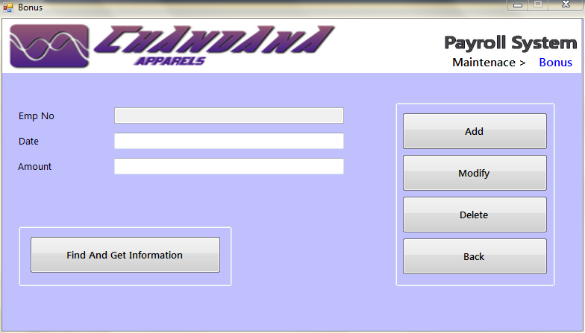

Screen 13 Salary

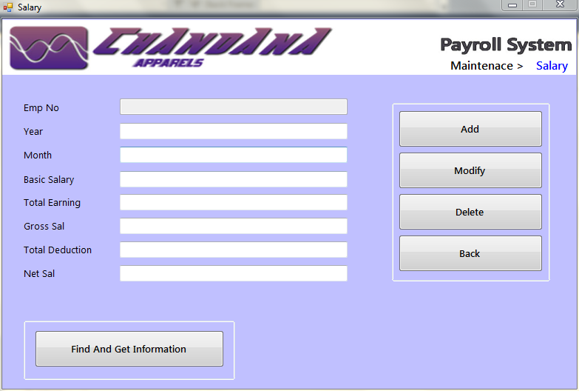

Screen 14 EPF

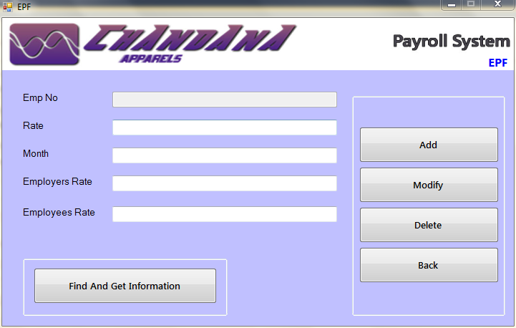

Screen 15 ETF

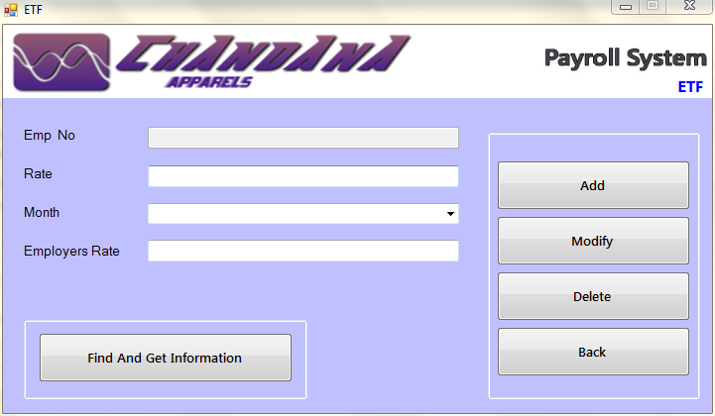

Screen 16 OT

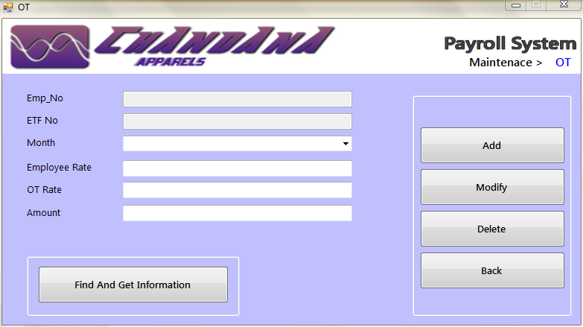

Screen 17 No pay

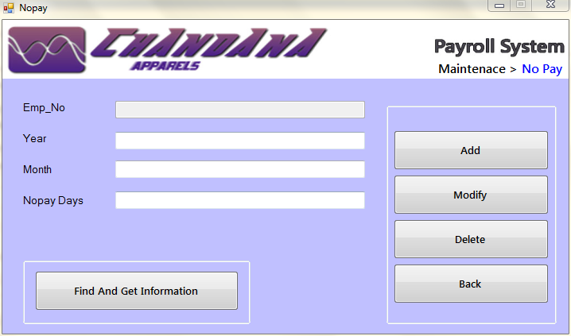

Screen 18 Work hour

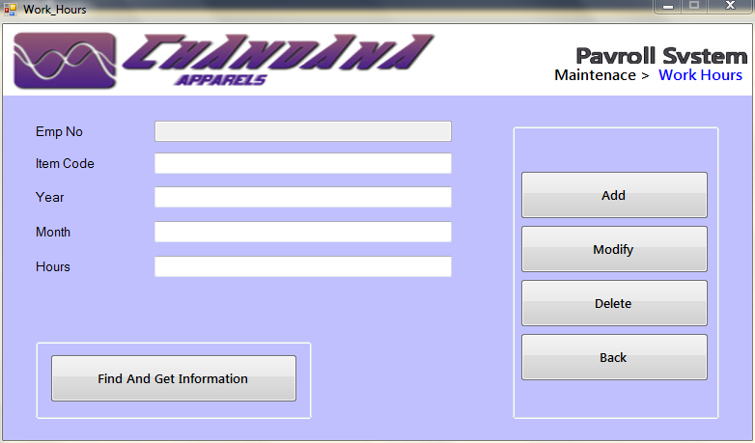

Screen 19 Leave Details

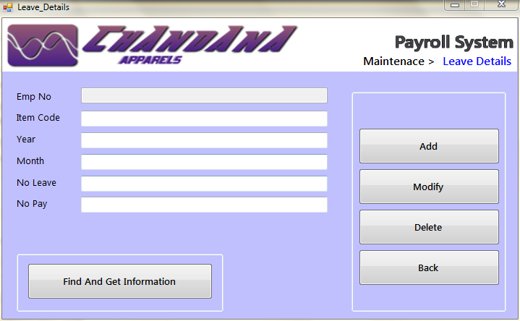

Screen 20 Increment

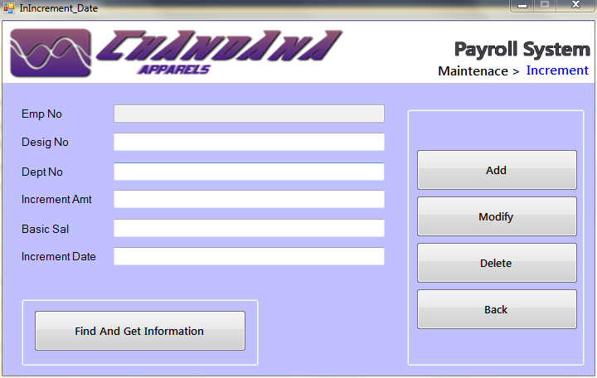

Screen 21 Promotion

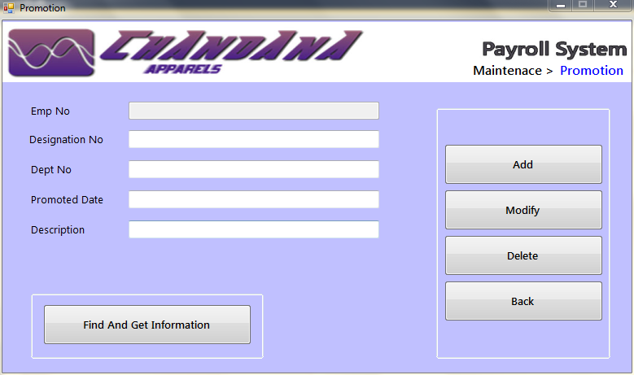

Message Screen List

|  |  |  |
| --- | --- | --- |
| **Screen No** | **Screen Name** | **Page No** |
| MS1 | No Input |  |
| MS2 | Already Exist |  |
| MS3 | Record Added Successfully |  |
| MS4 | Record Update Successfully |  |
| MS5 | Record Delete Successfully |  |
| MS6 | Invalid Input |  |
| MS7 | Authentication Failure |  |
| MS8 | Signup Success |  |

Message Screen 1 No Input

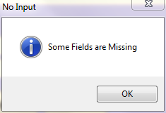

Message Screen 2 Already Exist

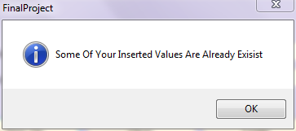

Message Screen 3 Record Added Successfully

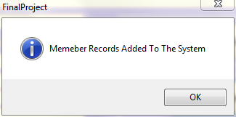

Message Screen 4 Record Update Successfully

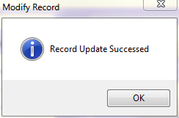

Message Screen 4 Record Delete Successfully

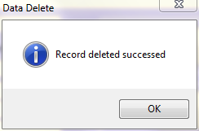

Message Screen 4 Invalid Input

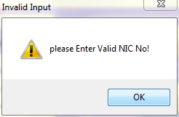

Message Screen 4 Authentication Failed

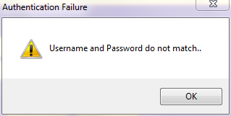

Message Screen 4 Signup Complete

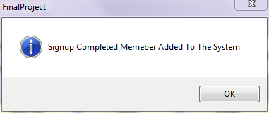

Chapter 4 Design of the proposed system

Reports

Reports List

|  |  |  |
| --- | --- | --- |
| **Report No** | **Report Name** | **Page No** |
| R1 | EPF Report |  |
| R2 | ETF Report |  |
| R3 | OT Report |  |
| R4 | Remittance Report |  |
| R5 | No pay Report |  |
| R6 | Payment Report |  |

Report 1 EPF Report

**Report ID: 01**

**Report Name: EPF report**

**Report Description: EPF details**

**Chandana Apparel (pvt) Ltd.**

Ganewatta Road,

Kurunegala.

EPF Report

EPF Report for the month of …………………………………………… year……………………………………….

|  |  |  |  |  |  |
| --- | --- | --- | --- | --- | --- |
| Employee No | EPF No | Basic Salary | Employers Contribution To EPF | Employees Contribution To EPF | Total Contribution To EPF |
|  |  |  |  |  |  |

………………………………………….

HRM Manager

Report 2 ETF Report

**Report ID: 02**

**Report Name: ETF report**

**Report Description: ETF details**

**Chandana Apparel (pvt) Ltd.**

Ganewatta Road,

Kurunegala.

ETF Report

ETF Report for the month of …………………………………………… year……………………………………….

|  |  |  |  |  |  |
| --- | --- | --- | --- | --- | --- |
| Employee No | ETF No | Basic Salary | Employers Contribution To ETF | Employees Contribution To ETF | Total Contribution To ETF |
|  |  |  |  |  |  |

………………………………………….

HRM Manager

Report 3 OT Report

**Report ID: 03**

**Report Name: OT report**

**Report Description: OT details**

**Chandana Apparel (pvt) Ltd.**

Ganewatta Road,

Kurunegala.

OT Report

OT Report for the month of …………………………………………… year……………………………………….

|  |  |
| --- | --- |
| Employee No | OT Hours |
|  |  |

………………………………………….

HRM Manager

Report 4 Remittance Report

**Report ID: 04**

**Report Name: Remittance list**

**Report Description: Sent salary info**

**Chandana Apparel (pvt) Ltd.**

Ganewatta Road,

Kurunegala.

Remittance Report

Remittance list for the month of …………………………………………… year……………………………………….

|  |  |  |
| --- | --- | --- |
| Emp No | Account Number | Amount |
|  |  |  |

………………………………………….

HRM Manager

Report 4 Remittance Report

**Report ID: 04**

**Report Name: Pay report**

**Report Description: Pay details**

**Chandana Apparel (pvt) Ltd.**

Ganewatta Road,

Kurunegala.

Pay sheet

Pay sheet Report for the month of …………………………………………… year……………………………………….

|  |  |  |  |  |  |  |  |  |  |
| --- | --- | --- | --- | --- | --- | --- | --- | --- | --- |
| Emp No | Name | OT Hours | No Pay Days | Basic Sal | OT Amount | Gross Salary | EPF Contribution | No Pay Amount | Net Salary |
|  |  |  |  |  |  |  |  |  |  |

………………………………………….

HRM Manager